Psychological statistics
Homework Assignment ④
B812109041 Isaac, Lee
WII
- Hypothesis
- Comparison between Athletes and Non-Athletes:
H0: There is no difference in pain scores between athletes and non-athletes.
Ha: There is a difference in pain scores between athletes and non-athletes.
- Comparison between Stretching and No Stretching:
H0: There is no difference in pain scores between those who stretched and those who did not stretch.
Ha: There is a difference in pain scores between those who stretched and those who did not stretch.
- Check Normality and Homogeneity
- Normality
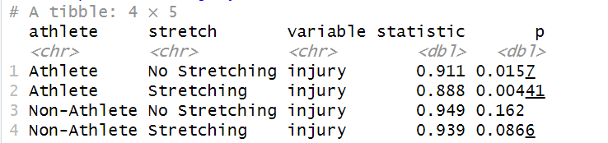
The results indicate that the distribution of injury scores does not follow a normal distribution in “Athlete” groups. (p < 0.05)
- Homogeneity of Variance
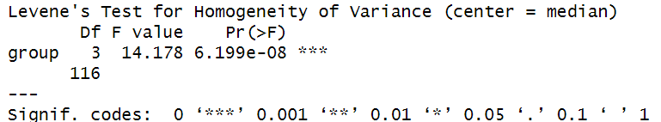
The results indicate that the variances are not equal among different groups (p < 0.05)
- Kruskal-Wallis test and Post-hoc Tests
Comparison between athletes and non-athletes:
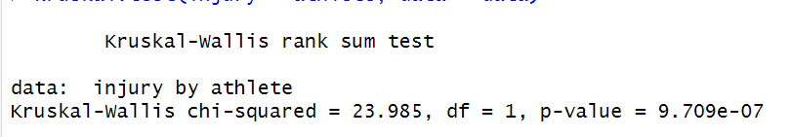
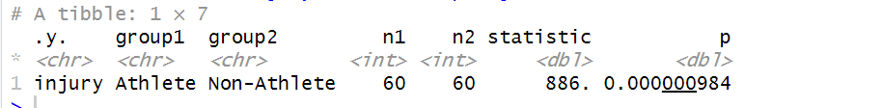
Kruskal-Wallis Test Results:
Since the p-value is very small (much less than 0.05), we reject the null hypothesis, indicating a significant difference in injury severity between athletes and non-athletes.
Wilcoxon Rank-Sum Test Results:
Since the p-value is very small (much less than 0.05), we again reject the null hypothesis, further confirming that there is a significant difference in injury severity between athletes and non-athletes.
Comparison between the prevention program group and the control group:
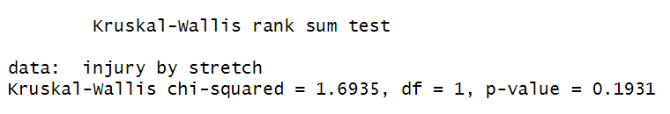
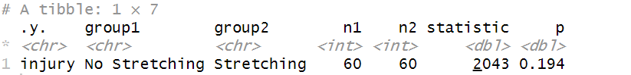
Kruskal-Wallis Test Results:
Since the p-value is greater than 0.05, we fail to reject the null hypothesis, indicating no significant difference in injury severity between the stretching and no stretching groups.
- Effect Size
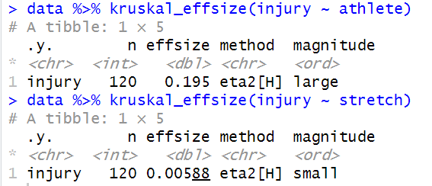

- Conclusion
In summary, there is a significant difference in injury severity between athletes and non-athletes, while there is no significant difference in injury severity between the prevention program group and the control group.

MUSICAL TASTES
- Hypothesis
H0-1: Age has no effect on music liking, the mean music ratings of the young group and the older group are equal.
H0-2: Music genre has no effect on music liking, the mean music ratings of the three music genres are equal.
H0-3: There is no interaction between age and music genre, the effect of age on music ratings does not vary by music genre.

- Check Normality and Homogeneity
- Normality
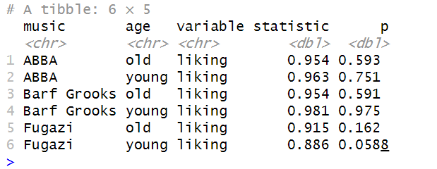
The p-values of the Shapiro-Wilk test are all greater than 0.05, except for the "Fugazi - young" group, where the p-value is 0.0588. Although this is close to 0.05, it is still greater than 0.05. This indicates that the music likiing for most groups follow a normal distribution.

- Homogeneity of Variance
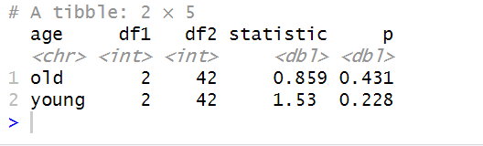
The p-values of the Levene's test are all greater than 0.05, indicating that the music ratings have equal variances across different age groups.

Since most groups follow a normal distribution and all groups have equal variances, we can use a two-way ANOVA to examine the effects of age and music genre on music ratings, as well as the interaction between them.

- Two-way ANOVA and Post-hoc Tests

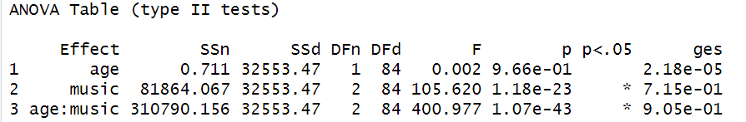

- The effect of age was not significant, F (1, 84) = 0.002, p = 0.966, indicating that age does not have a significant influence on music liking.
- The effect of music type was significant, F (2, 84) = 105.620, p < 0.001, suggesting that different music types have a significant impact on music liking.
- The interaction effect between age and music type was also significant, F (2, 84) = 400.977, p < 0.001, indicating that the combination of age and music type significantly influences music liking.

Post-hoc Tests
- Young Group
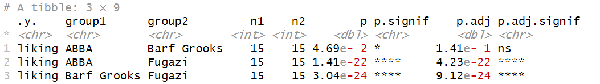
- ABBA vs. Barf Grooks: p < 0.05, significant difference
- ABBA vs. Fugazi: p < 0.05, significant difference
- Barf Grooks vs. Fugazi: p < 0.05, significant difference.

- Old Group
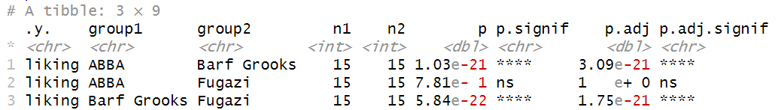
- ABBA vs. Barf Grooks: p < 0.05, significant difference
- ABBA vs. Fugazi: p > 0.05, no significant difference
- Barf Grooks vs. Fugazi: p < 0.05, significant difference.

- Effect Size
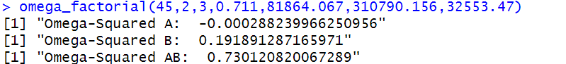
- Conclusion
The two-way analysis of variance (ANOVA) indicates significant effects of age, music type, and their interaction on music ratings. Further post-hoc tests reveal significant differences among different music types, and these differences may vary between the young and old groups. Specifically, in the young group, differences among all music types are significant, whereas in the old group, differences between ABBA and Barf Grooks, and between Barf Grooks and Fugazi are significant, but the difference between ABBA and Fugazi is not. The Omega-squared value for the interaction between age and music type (AB) is 0.730, indicating that this interaction accounts for 73.0% of the total variance, which demonstrates that the interaction effect is quite significant.
TEXT MESSAGE
In this scenario, we can use two-way repeated measures ANOVA. This is because there are two independent variables (factors) being manipulated:
1. Text messaging use (encouraged vs. forbidden)
2. Time point (before vs. after the experiment)
The dependent variable is the grammatical test scores measured before and after the experiment. By using a two-way repeated measures ANOVA, we can assess the main effects of text messaging use and time point on the grammatical test scores, as well as any interaction effect between these two factors.

- Hypothesis
- H01: There is no significant difference in mean scores among different groups across different time points.
- H02: There is no significant difference in mean scores across different time points within each group.
- H03: There is no significant difference in the change of mean scores across different time points among different groups.
- Check Normality
Three groups show p-values greater than 0.05, but for the "Text Messagers" group at "Six_months," the p-value for the score is less than 0.05, indicating non-normal distribution. As most of the data conforms to a normal distribution, a 2-way Repeated-measures ANOVA will be used for further analysis.
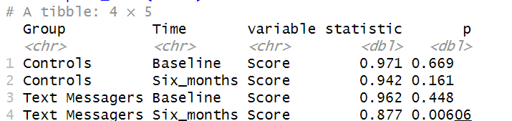
- Two-way repeated measures ANOVA.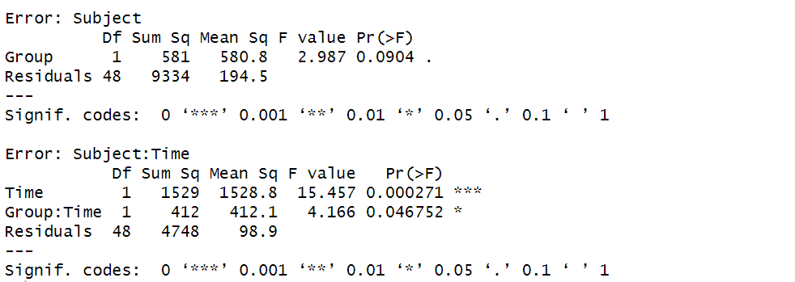
- Error term of Subject:
Group: The F-value for the factor Group is 2.987, with a p-value of 0.0904, indicating non-significance (p > 0.05). This suggests that the variance difference between different groups is not significant.
- Error term of Subject:Time:
Time: The F-value for the factor Time is 15.457, with a p-value of 0.000271, indicating high significance (p < 0.001). This implies that the variance differs significantly across different time points.
Group:Time: The F-value for the interaction between Group and Time is 4.166, with a p-value of 0.046752, indicating significance (p < 0.05). This suggests that the interaction between group and time significantly affects the results.
- Post-hoc Tests
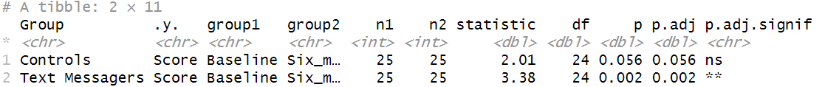
The results indicate that, in the Controls group, the difference in scores between Baseline and Six_months is not statistically significant (p = 0.056). However, in the Text Messagers group, the difference in scores between Baseline and Six_months is significant (p = 0.002).

- Conclusion
In the “Text Messagers” group, there was a significant regress in English grammar scores after six months, while in the Controls group, this improvement was not as pronounced. This may imply a positive impact of sending text messages on children's learning of English grammar.

